МИНИСТЕРСТВО ОБРАЗОВАНИЯ РЕСПУБЛИКИ БЕЛАРУСЬ

УЧРЕЖДЕНИЕ ОБРАЗОВАНИЯ

 «БРЕСТСКИЙ ГОСУДАРСТВЕННЫЙ ТЕХНИЧЕСКИЙ УНИВЕРСИТЕТ»

Кафедра ИИТ

\

ЛАБОРАТОРНАЯ РАБОТА №1-2

По дисциплине: «ОСИСП»

Выполнил:

Студент ФЭИС

3-го курса, группы ПО-5

Брич М.Н.

Проверила:

Дряпко А.В.

Брест 2021

**Цель работы:** приобрести практические навыки проектирования и разработки приложений с графическим

пользовательским интерфейсом в ОС Windows средствами Qt

Вариант 3

*Задание:*

Игра «Змейка».  
***snake.h:***

#ifndef MAINWINDOW_H

#define MAINWINDOW_H

#include <QMainWindow>

#include <QPaintEvent>

#include <QKeyEvent>

#include <QDialog>

#include <QComboBox>

#include "interface.h"

const int BLOCK_SIZE=15;

const int MARGIN=22;

const int AREA_ROW=30;

const int AREA_COL=30;

const int TIME_INTERVAL=100;

enum Direction

{

UP,

DOWN,

LEFT,

RIGHT

};

QT_BEGIN_NAMESPACE

namespace Ui { class MainWindow; }

QT_END_NAMESPACE

class MainWindow : public QMainWindow

{

Q_OBJECT

public:

MainWindow(QWidget *parent = nullptr);

~MainWindow();

virtual void paintEvent(QPaintEvent *event);

virtual void keyPressEvent(QKeyEvent *event);

QDialog dlg;

QComboBox* modeMenu = new QComboBox;

public:

void InitMenu();

void SetPlugins();

void InitGame();

void InitPause();

void PauseResumeGame();

void GameOver();

void GenerateFood();

void GenerateSnake();

bool IsGameOver();

private slots:

void SnakeUpdate();

void aboutQt();

void applyPlugin(int index);

void BtnDlgClick1();

void BtnDlgClick2();

void BtnDlgClick3();

void LoadingLevel();

void CheckUpdate();

private:

Ui::MainWindow*ui;

QTimer *gameTimer;

bool isPause;

QPoint foodPoint;

QList<QPoint> wall;

QList<QPoint> snake;

Direction dir;

int score;

int level;

QVector< Interface* > mPlugins;

};

#endif // MAINWINDOW_H

***menu.cpp:***

#include <QPainter>

#include <time.h>

#include <QTimer>

#include <QString>

#include <QtWidgets>

#include <QMessageBox>

#include "snake.h"

#include "ui_snake.h"

typedef void (*about)();

typedef bool (*GenerateWall)(int level, int i, int j);

typedef int (*countLevel)();

void MainWindow::SetPlugins()

{

QDir *dir;

#ifdef QT_DEBUG

dir = new QDir("/home/eve9te/bstu/osisp2.0/Snake/plugins/debug");

#else

#ifdef QT_RELEASE

dir = new QDir("/home/eve9te/bstu/osisp2.0/Snake/plugins/release");

#endif

#endif

if(dir->entryList(QDir::Files).isEmpty())

qDebug() << "dir isEmpty";

foreach(QString str, dir->entryList(QDir::Files))

{

QPluginLoader loader(dir->absoluteFilePath(str));

QObject *object = qobject_cast<QObject*>(loader.instance());//извлекаем плагин

Interface *plugin = qobject_cast<Interface*>(object);//приводим к интерфейсу игры

if(plugin)

{

this->mPlugins.push_back(plugin);

// const char * namePlugin = plugin->pluginName().toLocal8Bit().data();

// QAction *applyPlugin = new QAction(tr(namePlugin), this);

modeMenu->addItem(plugin->pluginName());

connect(modeMenu, SIGNAL(activated(int)), this, SLOT(applyPlugin(int)));

}

else

{

qDebug() << "error";

}

}

delete dir;

}

void MainWindow::applyPlugin(int index)

{

QFont palette = this->mPlugins[index]->changeView();

QApplication::setFont(palette);

}

void MainWindow::InitMenu()

{

dlg.setWindowTitle(tr("Выбирите уровень"));

dlg.setFixedSize(QSize(MARGIN*7+(AREA_COL+1)*BLOCK_SIZE,MARGIN*2+AREA_ROW*BLOCK_SIZE));

dlg.setGeometry(

QStyle::alignedRect(

Qt::LeftToRight,

Qt::AlignCenter,

dlg.size(),

QApplication::desktop()->availableGeometry(this)

)

);

QBoxLayout* layout = new QVBoxLayout;

layout->setAlignment(Qt::AlignVCenter);

QMenuBar* menuBar = new QMenuBar();

QMenu* menu = new QMenu("О программе");

menuBar->addMenu(menu);

menu->addAction("about.dll", this,SLOT(aboutQt()),

Qt::CTRL + Qt::Key_Q);

layout->setMenuBar(menuBar);

QPushButton* btn_easy = new QPushButton("Easy");

QPushButton* btn_medium = new QPushButton("Medium");

QPushButton* btn_hard = new QPushButton("Hard");

QPushButton* btn_update = new QPushButton("Update");

btn_update->setContentsMargins(QMargins(0,30,0,0));

QPushButton* btn_exit = new QPushButton("Exit");

// btn_exit->setStyleSheet("margin-top: 5px;"

// "padding-top: 3px; padding-bottom: 3px;");

connect(btn_easy, SIGNAL(clicked()), this, SLOT(BtnDlgClick1()));

connect(btn_medium, SIGNAL(clicked()), this, SLOT(BtnDlgClick2()));

connect(btn_hard, SIGNAL(clicked()), this, SLOT(BtnDlgClick3()));

connect(btn_update, SIGNAL(clicked()), this, SLOT(CheckUpdate()));

connect(btn_exit, SIGNAL(clicked()), &dlg, SLOT(close()));

layout->addWidget(btn_easy);

layout->addWidget(btn_medium);

layout->addWidget(btn_hard);

layout->addWidget(btn_update);

layout->addWidget(btn_exit);

layout->addWidget(modeMenu);

dlg.setLayout(layout);

if(dlg.exec() == QDialog::Accepted) {

InitGame();

}

else

{

exit(0);

}

}

void MainWindow::BtnDlgClick1()

{

level = 1;

LoadingLevel();

}

void MainWindow::BtnDlgClick2()

{

level = 2;

LoadingLevel();

}

void MainWindow::BtnDlgClick3()

{

level = 3;

LoadingLevel();

}

void MainWindow::LoadingLevel()

{

QLibrary *helperLib = new QLibrary("helper");

if (!helperLib->load())

qDebug() << helperLib->errorString();

if (helperLib->load())

qDebug() << "library loaded";

countLevel countLevel_ = (countLevel) helperLib->resolve("countLevel");

if(level > countLevel_())

{

QMessageBox msgBox;

msgBox.setWindowTitle("Error");

msgBox.setText("Уровень еще не добавлен");

msgBox.exec();

return;

}

GenerateWall generateWall_ = (GenerateWall)helperLib->resolve("GenerateWall");

for (int i = 0; i < AREA_COL; ++i) {

for (int j = 0; j < AREA_ROW; ++j) {

if(generateWall_(level, i, j)){

wall.push_back(QPoint(i, j));

}

}

}

delete helperLib;

dlg.accept();

}

void MainWindow::CheckUpdate()

{

QMessageBox msgBox;

msgBox.setWindowTitle("Update");

msgBox.setText("This is latest version");

msgBox.exec();

}

void MainWindow::aboutQt()

{

QLibrary *aboutLib = new QLibrary("about");

if (!aboutLib->load())

qDebug() << aboutLib->errorString();

if (aboutLib->load())

qDebug() << "library loaded";

about showWindowAboutProgramm = (about)aboutLib->resolve("about");

showWindowAboutProgramm();

delete aboutLib;

}

MainWindow::~MainWindow()

{

delete ui;

}

***snake.cpp***

#include <QPainter>

#include <time.h>

#include <QTimer>

#include <QString>

#include <QtWidgets>

#include <QMessageBox>

#include "snake.h"

#include "ui_snake.h"

MainWindow::MainWindow(QWidget *parent): QMainWindow(parent), ui(new Ui::MainWindow)

{

ui->setupUi(this);

setFixedSize(QSize(MARGIN*7+(AREA_COL+1)*BLOCK_SIZE,MARGIN*2+AREA_ROW*BLOCK_SIZE));

SetPlugins();

InitMenu();

}

void MainWindow::GameOver()

{

gameTimer->stop();

QMessageBox::information(this,"Failed","Game over!");

InitMenu();

}

void MainWindow::PauseResumeGame()

{

if(!isPause)

{

isPause=!isPause;

gameTimer->stop();

InitPause();

}

else

{

isPause=!isPause;

gameTimer->start(TIME_INTERVAL);

}

}

void MainWindow::InitPause()

{

QMessageBox::StandardButton pause;

pause = QMessageBox::question(this, "Pause", "Продолжить?",

QMessageBox::Yes|QMessageBox::No);

if (pause == QMessageBox::Yes) {

PauseResumeGame();

} else {

InitMenu();

}

}

***game.cpp***

#include <QPainter>

#include <time.h>

#include <QTimer>

#include <QString>

#include <QtWidgets>

#include <QMessageBox>

#include "snake.h"

#include "ui_snake.h"

typedef bool (*Generate_Snake)(int i);

void MainWindow::InitGame()

{

snake.clear();

GenerateSnake();

dir=RIGHT;

srand(time(0));

GenerateFood();

score=0;

isPause=false;

gameTimer=new QTimer(this);

connect(gameTimer, SIGNAL(timeout()), this, SLOT(SnakeUpdate()));

gameTimer->start(TIME_INTERVAL);

}

void MainWindow::GenerateSnake()

{

QLibrary *helperLib = new QLibrary("helper");

if (!helperLib->load())

qDebug() << helperLib->errorString();

if (helperLib->load())

qDebug() << "library loaded";

Generate_Snake generateSnake_ = (Generate_Snake)helperLib->resolve("GenerateSnake");

for (int i=AREA_COL;i>=0;i--) {

if(generateSnake_(i)){

snake.push_back(QPoint(i, 0));

}

}

delete helperLib;

}

void MainWindow::paintEvent(QPaintEvent *event)

{

Q_UNUSED(event);

QPainter painter(this);

painter.setBrush(Qt::yellow);

painter.setPen(Qt::blue);

painter.drawRect(MARGIN,MARGIN,AREA_COL*BLOCK_SIZE,AREA_ROW*BLOCK_SIZE);

painter.setBrush(Qt::blue);

painter.setPen(Qt::black);

for(int i=0;i<wall.size();i++)

painter.drawRect(MARGIN+wall[i].x()*BLOCK_SIZE,MARGIN+wall[i].y()*BLOCK_SIZE,BLOCK_SIZE,BLOCK_SIZE);

painter.setBrush(Qt::red);

painter.setPen(Qt::green);

for(int i=0;i<snake.size();i++)

painter.drawRect(MARGIN+snake[i].x()*BLOCK_SIZE,MARGIN+snake[i].y()*BLOCK_SIZE,BLOCK_SIZE,BLOCK_SIZE);

painter.setBrush(Qt::green);

painter.drawEllipse(MARGIN+foodPoint.x()*BLOCK_SIZE,MARGIN+foodPoint.y()*BLOCK_SIZE,BLOCK_SIZE,BLOCK_SIZE);

painter.setPen(Qt::black);

painter.setFont(QFont("Arial",14));

painter.drawText(MARGIN*3+AREA_COL*BLOCK_SIZE,MARGIN+2*BLOCK_SIZE,"score: "+QString::number(score));

}

void MainWindow::keyPressEvent(QKeyEvent *event)

{

switch(event->key())

{

case Qt::Key_Up:

if(dir!=DOWN)

dir=UP;

break;

case Qt::Key_Down:

if(dir!=UP)

dir=DOWN;

break;

case Qt::Key_Left:

if(dir!=RIGHT)

dir=LEFT;

break;

case Qt::Key_Right:

if(dir!=LEFT)

dir=RIGHT;

break;

case Qt::Key_P:

PauseResumeGame();

break;

case Qt::Key_Escape:

PauseResumeGame();

break;

default:

break;

}

}

bool MainWindow::IsGameOver()

{

int x=snake.front().x();

int y=snake.front().y();

if(x<0||x>AREA_COL-1||y<0||y>AREA_ROW-1)

return true;

for(int i=1;i<snake.size();i++)

if(snake[i]==snake.front())

return true;

for(int i=0;i<wall.size();i++)

if(wall[i]==snake.front())

return true;

return false;

}

void MainWindow::SnakeUpdate()

{

switch(dir)

{

case UP:

snake.push_front(QPoint(snake.front().x(),snake.front().y()-1));

break;

case DOWN:

snake.push_front(QPoint(snake.front().x(),snake.front().y()+1));

break;

case LEFT:

snake.push_front(QPoint(snake.front().x()-1,snake.front().y()));

break;

case RIGHT:

snake.push_front(QPoint(snake.front().x()+1,snake.front().y()));

break;

default:

break;

}

if(snake.contains(foodPoint))

{

score+=1;

GenerateFood();

gameTimer->start(TIME_INTERVAL - score);

}

else

snake.pop_back();

if(IsGameOver())

{

GameOver();

return;

}

update();

}

***food.cpp***

***#include <QPainter>***

***#include <time.h>***

***#include <QTimer>***

***#include <QString>***

***#include <QtWidgets>***

***#include <QMessageBox>***

***#include "snake.h"***

***#include "ui_snake.h"***

***void MainWindow::GenerateFood()***

***{***

***foodPoint.setX(rand()%AREA_COL);***

***foodPoint.setY(rand()%AREA_ROW);***

***if(snake.contains(foodPoint) || wall.contains(foodPoint))***

***GenerateFood();***

***}***

*Тестирование:*

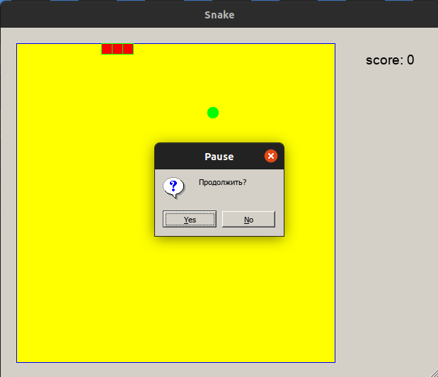

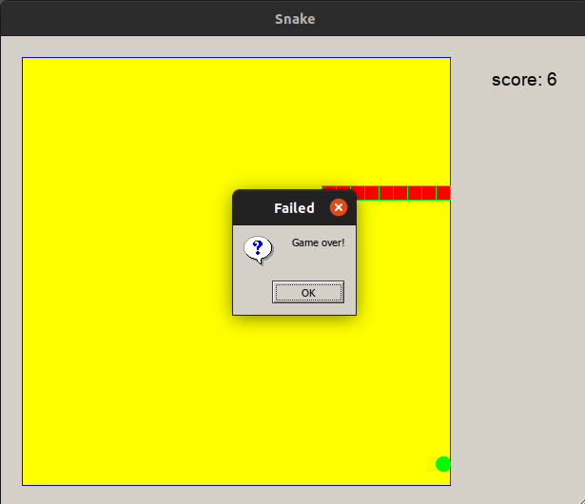

Вывод: приобрел практические навыки проектирования и разработки приложений с графическим пользовательским интерфейсом в ОС Windows средствами Qt.